Top 5 Office Projects Under Construction in Queens
Queens continues to expand its core areas, with 962,000 square feet of office space underway as of August, according to Yardi Matrix data.
SEP042020
By Corina Stef

The predominantly industrial Queens emerged as a top market for office construction activity in 2019 and has been slowly, yet boldly, changing its architectural blueprint. Although the coronavirus-induced halt on nonessential services temporarily stalled construction activity, developers still managed to complete some 1.5 million square feet of office space year-to-date through August, according to Yardi Matrix data. This includes Tishman Speyer’s 1.2 million-square-foot The Jacx, the second-largest office project in the market.

Two properties encompassing 90,000 square feet broke ground in 2020, and close to 962,000 square feet across seven properties were underway as of August. Most projects are redevelopments and expansions of former warehouses, a trend that neighboring Brooklyn has been experiencing as well. The lower-density Long Island City submarket led development activity due to its proximity to Manhattan. The list below highlights the top office projects underway in the market as of August, based on Yardi Matrix data.
5. KAUFMAN ASTORIA STUDIOS OFFICE
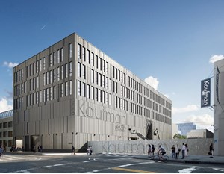
Kaufman Astoria Studios Office. Rendering courtesy of Gluck+ Architecture

Kaufman Astoria Studios is developing a four-story project in Queens’ Astoria submarket, at 34-12 36th St. Upon completion, scheduled for later in 2020, the property will total 97,000 square feet, including 65,000 square feet of office space, two film production studios and a 32,000-square-foot lunchroom. Signature Bank funded the construction with two loans totaling $40 million. Gluck+ Architecture handles the design services.

The property is taking shape on the site of a former gas station and auto repair shop. It is the latest addition to the 500,000-square-foot Kaufman Astoria Studios campus, the first studio in the five boroughs to feature a backlot for filming. The campus was originally built in 1920 as the home for Paramount Pictures.

4. QUEENS HEALTH CENTER
The New York Hotel and Motel Trades Council broke ground on the new, 90,000-square-foot Queens Health Center in January 2020. Located at 43-06 38th St., just south of Sunnyside Yard, the facility is adjacent to the current Queens Health Center at 37-11 Queens Blvd. and is expected to be completed in the first quarter of 2021. The three-story, $75 million medical office building will provide free medical, dental and optical care to more than 40,000 members of the New York hotel workers union as well as their families and retirees. Once complete, the developer plans to sell the facility to cover development costs.

3. 43TEN
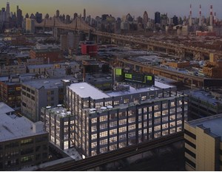
43TEN. Rendering courtesy of Columbia Property Trust

Normandy Real Estate Partners started work on 43TEN in September 2018. Last October, the company was acquired by Columbia Property Trust, which assumed management of all its assets, including the 203,184-square-foot upcoming creative office building. Completion of the seven-story property is scheduled for the first quarter of 2021.

AllianceBernstein originated a $66.1 million construction loan on behalf of the developer. Formerly a manufacturing site, the Mancini Duffy-designed asset is located at 43-10 23rd St. in Long Island City. It is one train stop away from midtown Manhattan and 15 minutes away by car or bike.

2. GANTRY POINT
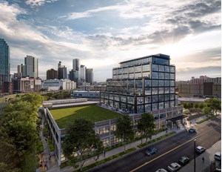Gantry Point. Rendering courtesy of Columbia Property Trust

The 237,718-square-foot Gantry Point is another creative office building originally developed by Normandy Real Estate Partners and subsequently transferred to Columbia Property Trust’s managed portfolio. Construction on the nine-story property started in February 2018, with completion scheduled for the end of 2020. Deutsche Bank provided $95 million in construction financing.

Gantry Point represents the redevelopment and expansion of an 87,000-square-foot warehouse. The asset is situated on 2 acres at 25-11 49th Ave., in Long Island City’s Hunters Point submarket, and is centrally located in a soon-to-be creative office hub influenced by the area’s industrial past.
1. INNOLABS
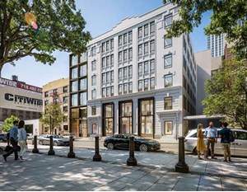
InnoLabs. Rendering courtesy of GFP Real Estate

The largest development on the list is King Street Properties and GFP Real Estate’s InnoLabs, an upcoming 266,800-square-foot life sciences facility in Long Island City. The project kicked off in December 2019 and represents the complete renovation and expansion of the 1920-built asset. The six-story project is expected to come online in the first quarter of 2021 and was financed by a $152.1 million construction loan provided by ACORE Capital.

InnoLabs is the New York City Economic Development Corp.’s first investment within the $500 million LifeSci NYC program. Situated at 45-18 Court Square, it is near many historic Kips Bay hospitals in the borough’s emerging bioscience corridor.

