ACORE Lends $37M on Camp Margaritaville Central Florida

BY ANDREW COEN MARCH 31, 2022 2:11 PM
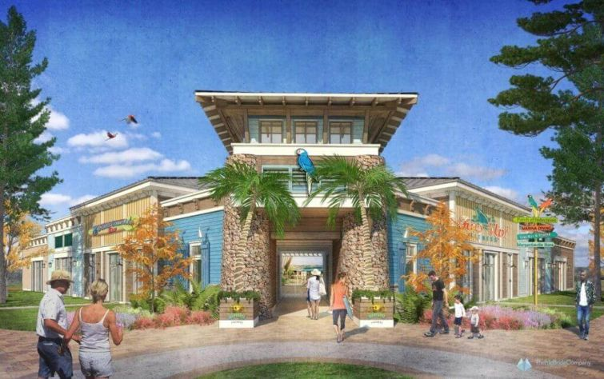
A RENDERING FOR CAMP MARGARITAVILLE CENTRAL FLORIDA. PHOTO: CENTRAL FLORIDA DEVELOPMENT COUNCIl
Randy Knapp’s RLK Real Estate & Development has nabbed a $37 million bridge and construction loan to finance the completion of its Camp Margaritaville Central Florida development, Commercial Observer can first report.
ACORE Capital provided the debt package for the planned 665.2-acre destination RV resort community in Auburndale, Fla. The bridge financing closed on March 22, with an initial term of three years and two one-year extension options.
Broadacre Financial arranged the transaction.
“The property and business plan are phenomenal, and having spent a considerable amount of time with the Knapp family during our diligence and closing process, we are certain that the deal will be a huge success,” Tony Fineman, senior managing director and co-head of originations at ACORE, said in a statement. “We were particularly impressed with the Knapp family’s incredible attention to every detail regarding the management and operation of the property, and their focus on maintaining the property’s appeal to the RV-ing community.”
The central Florida property marks the third RV resort for Margaritaville, a lifestyle brand that specializes in hospitality, dining and retail. The first phase of the park opened last March containing 183 RV spaces and 59 two-bedroom cabins. The new financing from this deal will fund the completion of the second phase slated for the first half of 2022, which contains 117 RV spaces and 41 cabins, and will open in the first half of 2022.
The resort will offer amenities that include clubhouse, resort-style pool, 147-foot water slide, splash pad and a walk-in pool. It will also feature a Feeding Frenzy Grill, Frank & Lola’s Pizzeria, Parrot Island Mini Golf, playground and dog parks.
“Camp Margaritaville is a game-changing concept, bringing nationally recognized branding and resort standards to the growing RV sector,” Chris Haynes, president of Broadacre, said in a statement. “The ACORE team understood the concept and was creative enough to finance a non-traditional product type on competitive terms.”
Knapp did not immediately return a request for comment.

